**BUS PASS WITH QR CODE**

**Samarth Saudagar Takbhate, GR no.: 11910739, Div: P , Roll no:69**

Department of Engineering, Sciences and Humanities (DESH)

**Abstract :-**

The online bus pass is a need of today.It helps passengers in the bus and also conductor.The purpose of developing this web app is to resolve following problem statements. 1)Long Queues for issuing bus passes. 2)Tedious processes for issuing and renewing the passes. 3)Passes are still physical slips of papers , not digital cards.

**Keywords**:-

Python language , pycharm.

* **Introduction**

This project ensures that the online bus pass will Reduce the time of transiction of passengers , and it is easy to operate . In Bus Pass Online Application Customer can buy the bus ticket over the Internet, 24 hours a day throughout the week, this solves the issue of bus ticket being misplaced or stolen. . Furthermore, customers no need to pay cash to buy bus ticket because they can pay the bus ticket by using Credit Card,online payment.

This web application keeps all information of all Bus pass. This online bus pass software system will help students and passengers get bus passes online and eliminate the need to stand in ques for passer or collecting a ticket for each journey. Passengers first need to login on the web application. Once loged in the system allows them to book passes for any route online.

Pass system projects that manages and provides various bus pas functionality. The project allows users to register on the bus pass website and interact online to manage their account and bus pass related transictions.

* **Implementation details**

This project contain web pages . The starting window is of login of the user and the registration of the new users.The new user have to first register and then they can login in the online bus pass web app .

After registration and login the user will get new window . In that window they will get 2 options . First one is the QR code . In that the user will get their personal unique QR code of bus pass for which they are logged in . In another option ,the user can get a new bus pass by giving proper information. I am taking the input from the users to make a unique QR code for them from which they can travel by bus by showing that QR code to the conductor.

The conductor will scan that QR code of passenger and conductor will get bus pass imformation on their mobile.

**Fig.1** :- It shows the main window of the project .

**Fig.2**:- The sign up module is shown. Two field are given for sign up which are filled by user.

**Fig.3**:- This figure shows the login window where user have to fill their username and password to login.

**Fig.4**:- After login this window will open. This window contain two options 1) My QR code 2) Get e pass

**Fig.5**:-This is the Get e pass window where user have to fill their proper information to generate a pass.

**Fig.6**:-This is a QR code which is unique for a user . The conductor of buss have scan this QR code to display e pass.

**Fig.7**:-This is a result of Scanned QR code.

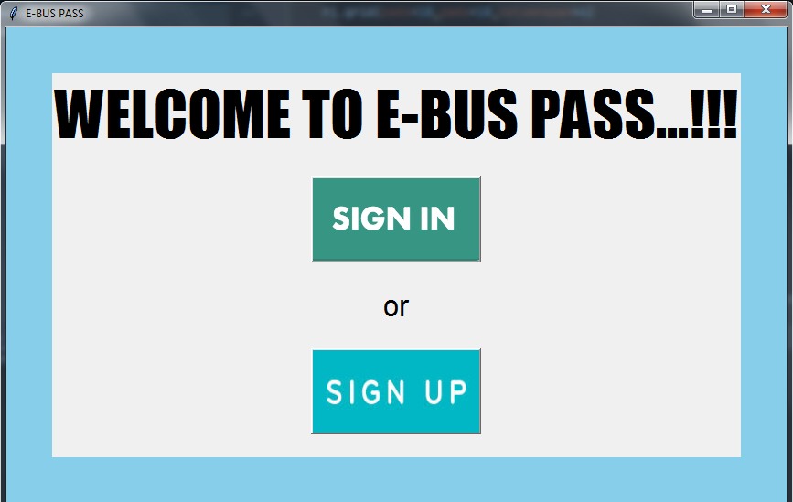 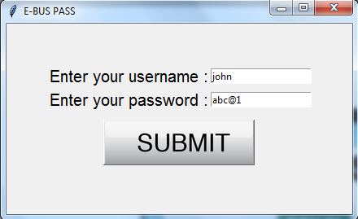

**Fig.1 Fig.2**

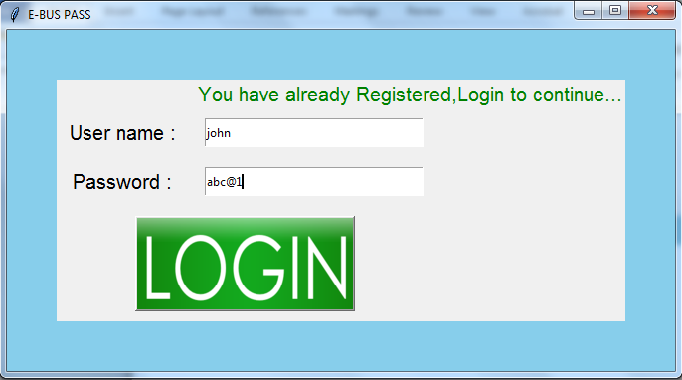 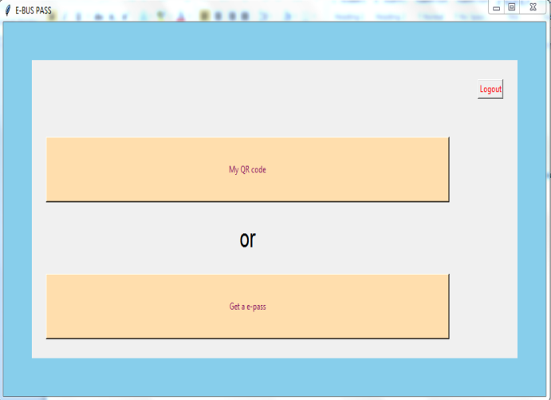

**Fig.3 Fig.4**

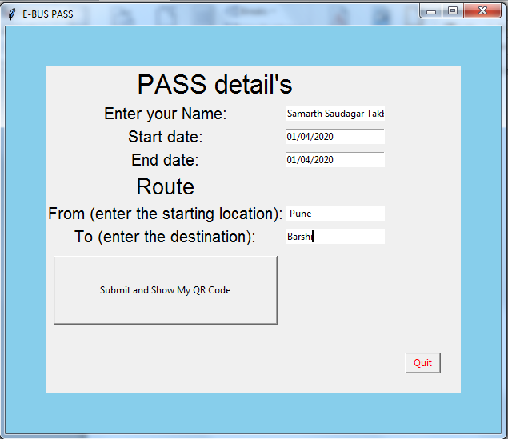

**Fig.5**

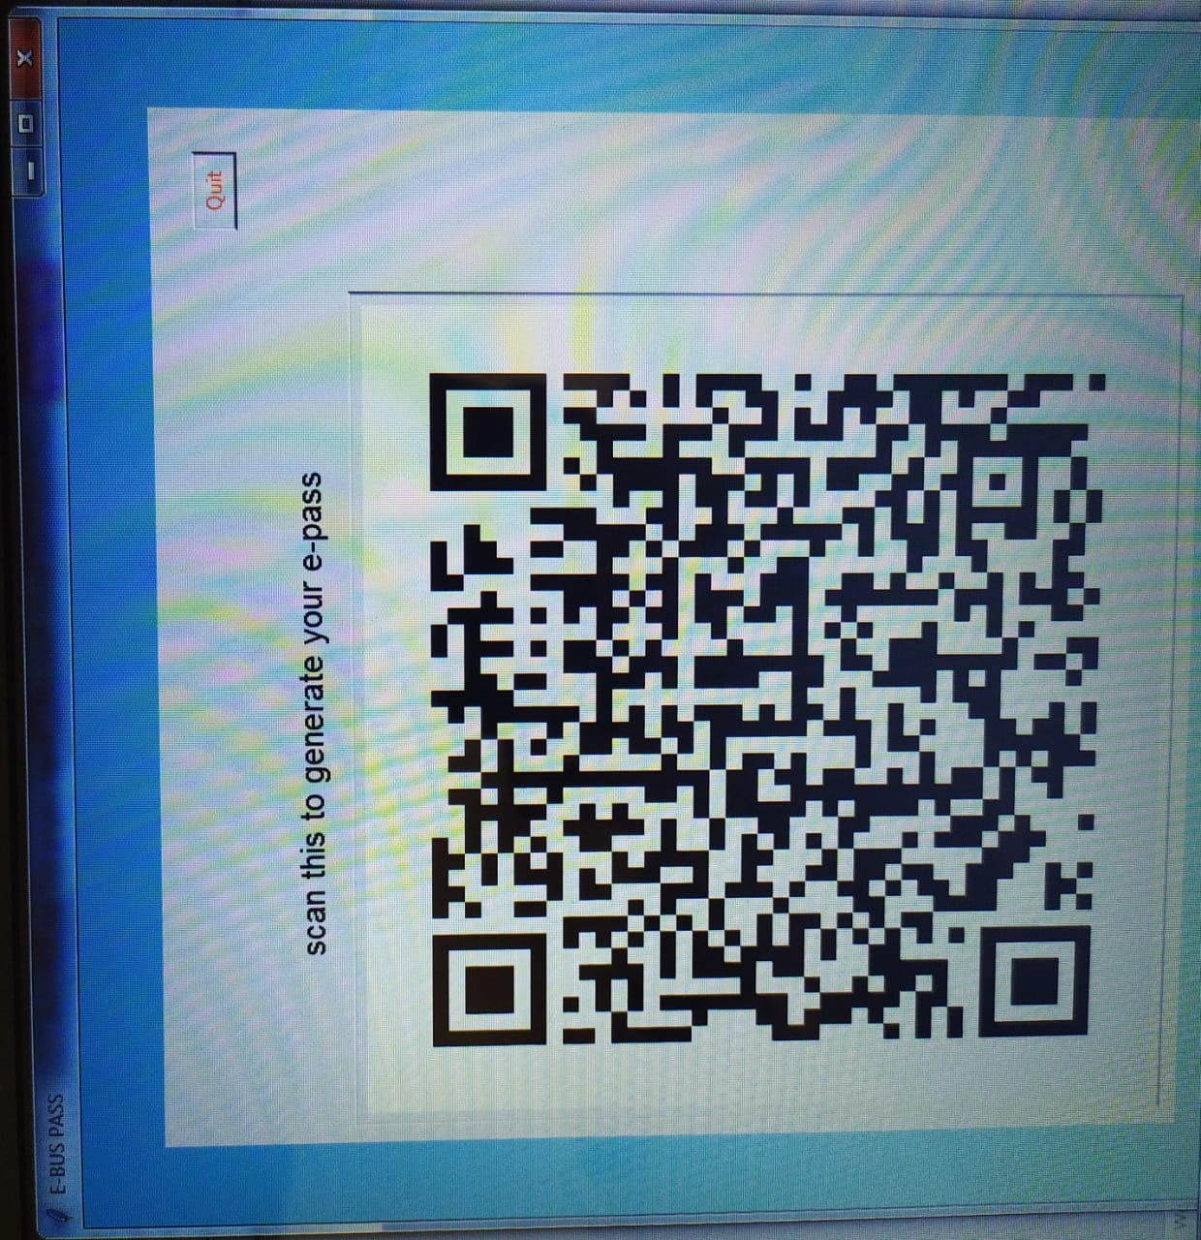 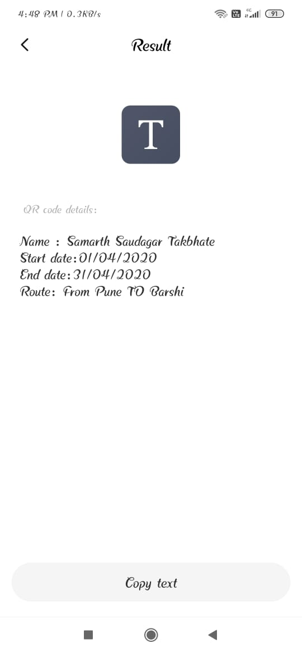

**Fig.6 Fig.7**

* **Results and discussion**

The application is developed using python language**.** This is a fully functioning web application. The data is stored and managed using file handling and with the help of csv library.This web application enables us to read and write the data and access it from the memory allocated to it.

All required information is stored in a text file and markup language is used for displaying the text. In the login section the credentials are checked. If the user is recognized, then it navigates to the user menu section but if the entered username or password is incorrect, then a window will pop up(Fig. 8) displaying a message of “Invalid username or password. Please try again.”

And also after logged out , the window will pop up (Fig.9) displaying a message of “ You have successfully logged out, Thank you for visiting E-buss pass!!!”.

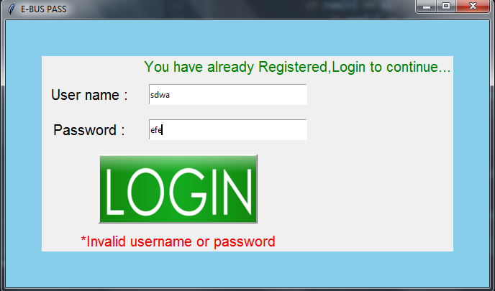 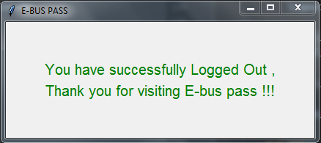

Fig.8 Fig.9

* **Conclusion and Future Scope**

It can be summarised that bus pass is a very important task which could be made easier using this web application.

An android application can be developed which could be accessible to every individual so that he / she can get bus pass easily . GPS tracking to the nearby buses to get updated imformation .The payment can be done online via credit or debit card . Smart card instead of print out of pass.

* **References**

1. <https://www.geeksforgeeks.org/>
2. <https://www.w3schools.com/>
3. <https://www.youtube.com/watch?v=QXeEoD0pB3E&list=PLsyeobzWxl7poL9JTVyndKe62ieoN-MZ3>
4. <https://www.javatpoint.com/python-tutorial>

……..